**Use Cases**

**UC1:** Find Nearby Charging Stations.

**Actor:** EV Driver

**Goal:** Locate available charging stations near current location.

**Flow:** User opens app → GPS detection → Map display → Filter application → Station selection

**UC2:** Plan Route with Charging Stops.

**Actor:** EV Driver

**Goal:** Plan optimal route with necessary charging stops.

**Flow:** Enter destination → Specify battery level → Calculate route → Confirm → Navigate

**UC3:** Make Payment for Charging.

**Actor:** EV Driver

**Goal:** Securely pay for charging services.

**Flow:** Initiate charging → View rates → Confirm payment → Process → Start charging

**UC4:** Manage Station Information.

**Actor:** Station Operator

**Goal:** Update station information and availability.

**Flow:** Login → Select station → Update info → Validate → Publish updates

**User Stories**

**EV Drivers:**

* US1: Find nearest available charging station quickly.
* US2: See real-time availability to avoid occupied stations.
* US3: Filter by connector type for compatibility.
* US4: Plan routes with charging stops for long journeys.
* US5: Pay through app without multiple cards.

**Station Operators:**

* US6: Update station availability for accurate information.
* US7: Set dynamic pricing to optimize revenue.

**System Administrators:**

* US8: Monitor system performance for optimal user experience.

**User Requirements**

**Functional Requirements**

1. Location Services: GPS-based station discovery with real-time availability.
2. Route Planning: Optimal route calculation considering vehicle range and traffic.
3. Payment Processing: Multi-method payment with PCI-DSS compliance [2].
4. Station Management: Real-time status updates from operators.
5. Cross-Platform Access: Responsive web application for all devices.

**Non-Functional Requirements**

1. Performance: <3 second response time, 50,000+ concurrent users.
2. Security: AES-256 encryption, HTTPS, OAuth 2.0 authentication.
3. Availability: 99.5% uptime with failover mechanisms.
4. Usability: WCAG 2.1 compliance [3], ≤3 clicks for key functions.

**Design Specifications**

**System Architecture**

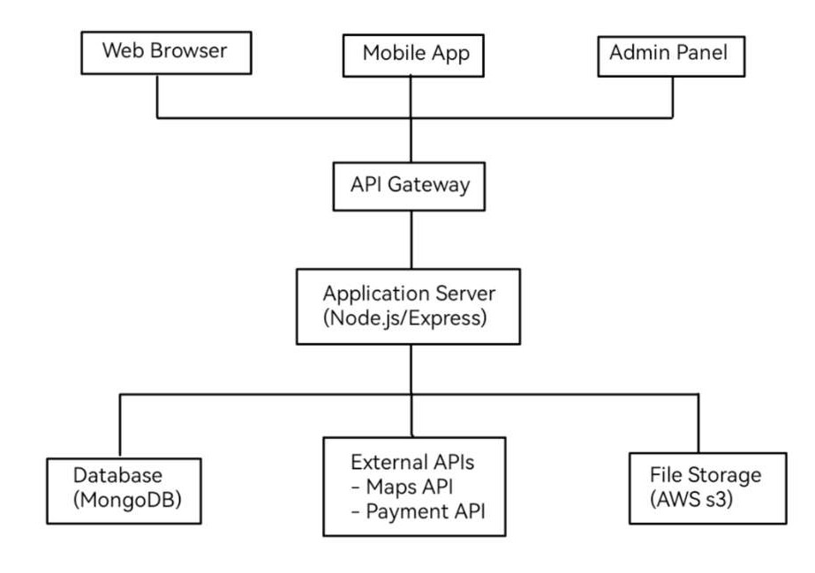

**Database Design**

**Key Collections:**

* Users: Profile, vehicle info, payment methods (_id: PRIMARY KEY, email: UNIQUE)
* Charging Stations: Location, operator details, connectors, status (_id: PRIMARY KEY, location: GEO INDEX)
* Sessions: Active charging sessions with tracking (session_id: PRIMARY KEY, user_id/station_id: FOREIGN KEYS)

**API Design**

**Core Endpoints:**

* GET /api/stations/nearby?lat={lat}&lng={lng}&radius={radius}
* POST /api/auth/login
* GET /api/routes/plan?origin={origin}&destination={dest}
* POST /api/payments/process
* PUT /api/stations/{stationId}/status

**Design Traceability Matrix**

|  |  |  |  |
| --- | --- | --- | --- |
| Use Case | User Stories | Requirements | Design Components |
| UC1: Find Stations | US1, US2, US3 | Location Services | Map API, GPS Service, Station Database |
| UC2: Route Planning | US4 | Route Optimization | Routing Algorithm, Traffic API |
| UC3: Payment | US5 | Payment Processing | Payment Gateway, Encryption |
| UC4: Station Management | US6, US7 | Station Updates | Admin Interface, Real-time Updates |

**References**

[1] Google Developers. (2024). Maps Platform Documentation. Google LLC. <https://developers.google.com/maps/documentation>

[2] Payment Card Industry Security Standards Council. (2022). Payment Card Industry Data Security Standard v4.0. <https://www.pcisecuritystandards.org/>

[3] World Wide Web Consortium. (2018). Web Content Accessibility Guidelines (WCAG) 2.1. <https://www.w3.org/TR/WCAG21/>